# Calculating digital bell filter coefficients for a specified value

*All calculations performed using https://www.wolframalpha.com/*

Equivalent analogue filter s-plane transfer is:

$$H\left(s\right)=\frac{s^{2}+\left(3-k\right)\frac{ω_{0}}{Q}s+{ω_{0}}^{2}}{s^{2}+\left(3-k\right)\frac{ω_{0}}{Q}+{ω_{0}}^{2}}$$

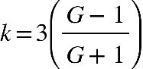

Q – Q factor

$ω_{0}$– centre frequency ( critical frequency )

**Let’s assume a gain of 20 dB and 125 Hz as centre frequency.**

To determine the coefficients, we first determine the pre-warped analogue transfer function.

Starting off by converting the gain to linear ratio:

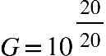 = 10.

From here,

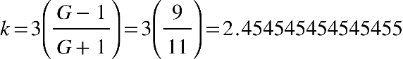

This means that H(s):

$$H\left(s\right)=\frac{s^{2}+\left(3+2.454545454545455\right)\frac{ω_{0}}{Q}s+{ω_{0}}^{2}}{s^{2}+\left(3-2.454545454545455\right)\frac{ω_{0}}{Q}+{ω_{0}}^{2}}$$

Then, for 20 dB and 125 Hz:

$$H\left(s\right)=\frac{s^{2}+5.45\frac{ω_{0}}{Q}s+{ω_{0}}^{2}}{s^{2}+0.55\frac{ω_{0}}{Q}+{ω_{0}}^{2}}$$

The pre-warped boost frequency is



Where T is the period and is the specified cut-off(critical frequency)

;  s

Then, inserting the values:



The frequency-scaled factor is:



The pre-warped analogue transfer function is:



Applying BZT method:



**For our case, with centre frequency at 125 Hz, gain of 20 dB and Q-factor of 1:**



Using Matlab to compute those coefficients:

Further calculations ( not sure if those should be included or not )

